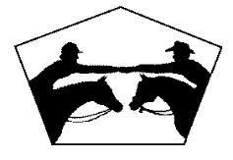
SANTA CRUZ COUNTY HORSEMEN’S ASSOCIATION

SHOWGROUNDS RENTAL CONTRACT
EVENT COORDINATOR
Name: Phone:
Mailing Address: E-Mail:
Event/Service Name: Board Member Sponsor:
Description:
Event Type: ☐ Clinic ☐ Horseshow ☐ Horse camping ☐ Other:
Event Dates: From _______________To _______________
Estimated Number of Participants: # Riders ____ # Auditors ___ (est) # Guests ________
FACILITIES
Only facilities checked may be used during event
☐ Paddocks/Camping Area OR ☐ Day Use Staging only (no camping)
# Paddocks for Camping ☐ Bathrooms, Showers, & Wash Rack (Please be water-wise!)
☐ Dressage Arena ☐ Large Arena ☐ Both Arenas ☐ No Arenas ☐ Round Pens ☐ Cattle Pens
☐ Clubhouse (B.O.D. approval) ☐ BBQ/Outdoor Kitchen ☐ _______________ ☐ ALL Facilities
EVENT FEES
$ _____ Facility Fees (see Facility Fee Schedule) - based on facilities selected above, excluding Use Fees (see below)
$ _____ Security Deposit (Separate Check) – to be refunded after event if areas are left clean, undamaged and any items used are returned to the proper storage location
- Security deposit must be received at the time of the booking.
- Facility fees must be received no less than 30 days prior to event.
- Fees will be refunded in full if event is cancelled due to rain.
- Fees will be returned, less $25, if event is cancelled by Event Coordinator more than 30 days prior to event.
- 50% of facility fees will be returned, if event is cancelled by Event Coordinator less than 30 days prior to event.
USE FEES - to be paid upon arrival at SCCHA
 |  | Non-Member  (18 and over) | Non-Member (under 18) | SCCHA Member
CAMPING | Per Night/person (incudes 1 horse)  Per Night/Each additional Horse  Reserved Paddocks per night/Horse  Per Night/extra person - no horse | $25  $5  $15  $10 | $10  $5  $15  N/A | No Charge  No Charge  $15  No Charge
DAY USE | Per day/person (includes 1 horse) | $10 | No Charge | No Charge
AUDITOR | Per day/person (no horse) | $5 | No Charge | No Charge
- Event Coordinator is responsible for collecting prior to the event, Camping, Day Use, Auditor fees, a signed SCCHA Liability Waiver & Rules from each participant, auditor and volunteer. The SCCHA Liability Waiver & Rules Governing Grounds Use are attached (exhibit 1 & 2). And, ensure any member participants are active members with the signed documents. Event Coordinator will ensure parking passes are used at the showgrounds.
- All checks shall be made payable to SCCHA, with event name in the memo line.
- Event Coordinator shall compile a Use Report of Campers, Day Use and Auditors with arrival/departure dates. Signed SCCHA Liability waivers and Use Report shall be remitted to SCCHA by the last day of each event.
INSURANCE REQUIREMENTS – For any event with a registration or entry fee
Clinicians and Groups wishing to rent the GRAHAM HILL SHOWGROUNDS COUNTY EQUESTRIAN PARK must carry their own insurance with a minimum coverage of $2,000,0000 General Aggregate and $1,000,000 each occurrence. Certificates must be received by the Calendar Secretary at least 30 days BEFORE the event. Two Certificates of Insurance are required:
- This exact wording is required on the Certificate of Insurance, and is to be sent to SCCHA as Certificate Holder:
“Santa Cruz County Horsemen's Association, it's officers, agents, employees and volunteers are additional insured.” Mail or deliver to: SCCHA – Attn: Calendar Secretary, 1145 Graham Hill Road, Santa Cruz CA 95060

- This exact wording is required on the Certificate of Insurance, and is to be sent to the County of Santa Cruz, as Certificate Holder: “The County of Santa Cruz, its officers, agents, and employees are additional insured.”
Mail or deliver to: Santa Cruz Co. Parks Dept. -- Attn: Director of County Parks, 979 17th Avenue, Santa Cruz, CA 95062

ADDITIONAL REQUIREMENTS
- All Rules Governing Grounds Use of the Santa Cruz County Horsemen’s Association will be adhered to; anyone found in violation of these rules will be asked to leave and event may be terminated. Future requests to hold events at this facility will be affected by your group’s adherence to these rules. Rules Governing Ground Use is attached (exhibit 2), some items of which are repeated for emphasis below.
Horses may NOT be left unattended at the showgrounds without adult supervision. Overnight campers must be at least 100 feet from the fence of our neighbors (to the west). Quiet time starts at 10pm: no noise past this time.
Dogs must be on leash at all times. No smoking.
- Minimizing dust is essential. If arenas or other area on grounds becomes very dusty, event coordinator must contact caretaker or board member to provide water to area.
- If a PA system is used, volume must be kept reasonable and speakers pointed away from neighboring homes.
- All facilities used by this event will be left clean and in the condition in which they were received. Manure and bedding must be cleaned from all paddocks and areas used, including areas where horses are tied. Manure must be taken to the manure bunker; never scattered in the trees or elsewhere.
- All trash and recyclables must be deposited in the waste cans near the manure bin.
- All items used must be returned to their storage location. If used, the jump trailer must be stored back in its original corner, so that its side and back end are both within five feet of the fence.
- For events where the number of participants and spectators require extra toilets on site, event manager will be responsible for paying for and scheduling the delivery, cleanout and pick up of portable toilets.

CONTRACT SIGNATURE
In order to complete this agreement, initial each page where indicated (including exhibits), then sign below.
Return contract with fees and security deposit no later than 30 days prior to event.
MAKE CHECKS PAYABLE TO SCCHA, MAIL TO CALENDAR SECRETARY, 1145 GRAHAM HILL RD, SANTA CRUZ CA 95060
I have read and understand this agreement and all exhibits, find that all items are specified accurately for this event, and agree to abide by all of the stated requirements.
Event Coordinator SIGNATURE: Date:
For Official Office Use Only
SCCHA Signature: _________________________ $__________ Facility Fees Paid $__________ Deposit Paid
____ Insurance Received/Waived ____ SCCHA Insurance Provider Advised of Event

Exhibit 1
SANTA CRUZ COUNTY HORSEMEN’S ASSOCIATION

Waiver of Liability and Hold Harmless Agreement

Liability Waiver must be signed by each adult . The parent or legal guardian must sign for each junior/minor/dependent.

The undersigned states as follows: I acknowledge and understand that competitive and pleasure horse riding contains inherent risks of injury or death to me personally, to my horse, and to others, and damage of any nature to equipment and facilities, in any way connected with the events, camping, riding, walking, boarding, instruction, use of or proximity to trail obstacles and all other activities at or involved with the Santa Cruz County Horsemen's Association (SCCHA). I acknowledge that there are other risks, hazards and dangers that are associated with horse related activities. I further acknowledge and recognize that the description of the risks in this document are not a complete list and that there are other risks, hazards and dangers associated with equestrian activities that may be unknown or unanticipated and that the Santa Cruz County Horsemen's Association, its board of directors, officers, and all individual members thereof, the County of Santa Cruz, its officers, agents, employees, and their representatives, and all other persons and organizations shall not be liable for any damage which may arise from any cause or as a result of fire, theft, state of health, injury to person, horse or property. Furthermore, should emergency medical or other treatment be required, I understand that I, and/or my own accident/medical insurance company shall pay for all incurred expenses, including medical insurance deductibles.

Acknowledging these facts, I assume all risks, whether known or unknown in consideration of my agreement and signature below, hereby for myself, my heirs, executors, and administrators, agree to waive, release, indemnify, discharge and hold harmless the Santa Cruz County Horsemen's Association, its board of directors, officers, members and agents and the County of Santa Cruz, its officers, agents, employees, and their representatives. I hereby defend, indemnify and hold harmless the Santa Cruz County Horsemen's Association, it's owners, officers directors, members, and agents or any of them and the County of Santa Cruz, its officers, agents, employees, and their representatives against all claims, demands, and causes of action including any court costs and attorney fees, directly or indirectly arising from any action or other proceedings brought by or prosecuted for my benefit contrary to this release, extended to all claims of any kind and nature whatsoever whether known or unknown and expressly waive any benefits I may have under Section §1542 of the California Civil Code which states "A general release does not extend to claims which the creditor does not know or suspect to exist in his favor at the time of executing the release, which if known by him might have materially affected his settlement with the debtor."

I acknowledge and agree that this release and waiver of liability, assumption of risk, and indemnity agreement is governed by laws of the State of California and is intended to be as broad and inclusive as is permitted by law, and that in the event any portion of this release is determined to be invalid, illegal, or unenforceable for any reason, the balance thereof shall not be affected or impaired in any way and shall continue in full legal force and effect. I have read and agree to this Release of Liability in its entirety and know and understand its contents, including important limitations of legal liability.
Sign (Adult 1) __________________________________________________ Date ____________________
Print Last Name:__________________________________________ First Name: _______________________
Sign (Adult 2) ___________________________________________________ Date ____________________
Print Last Name:_________________________________________ First Name: ________________________
Legal Guardian Sign for Minor under 18 ______________________________ Date ____________________
Print Minor Last Name:____________________________________ First Name: ________________________
Legal Guardian Sign for Minor under 18 __________________________________ Date _______________
Print Last Name:_________________________________________________ First Name: _________________________

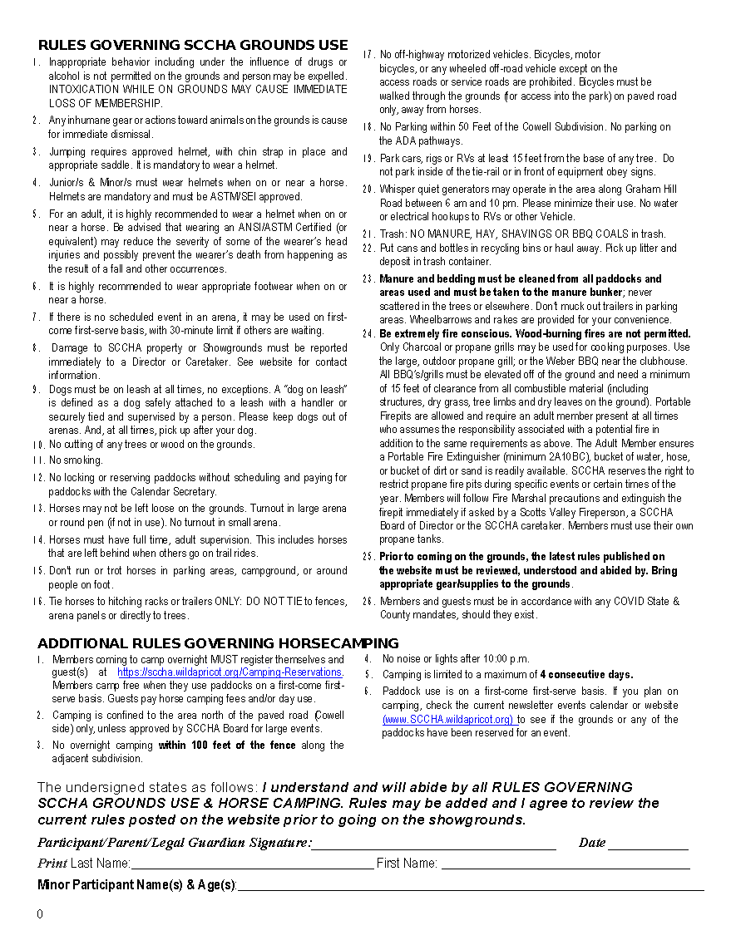
Exhibit 2

